Create an Azure AI Search Service
- Enter Azure Portal Login into Google Search and login to portal.

- Enter Azure AI Search into Azure Portal Search bar and select Azure AI Search.
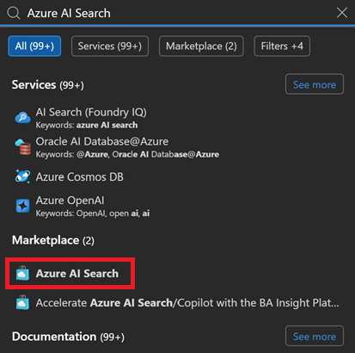

- Enter the following to create the Azure AI Search Service:
  - Select Azure Subscription.
  - Select Resource group.
  - Enter Service name.
  - Select service deployment Location.
  - Click Change Pricing Tier link.
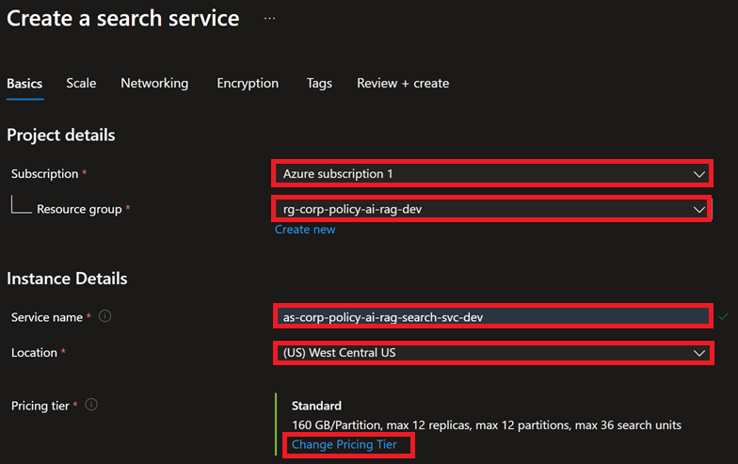
- Select the Serverless Developer pricing tier and click Select button.
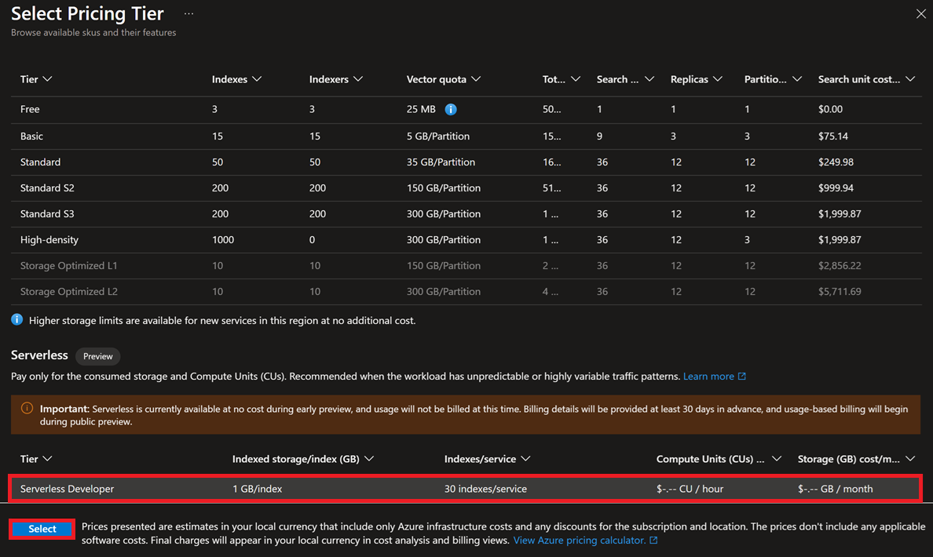
- Click Review + create button to create the search service.

- Review/confirm Pricing Tier and Estimated cost per month is correct. If so, click Create button.
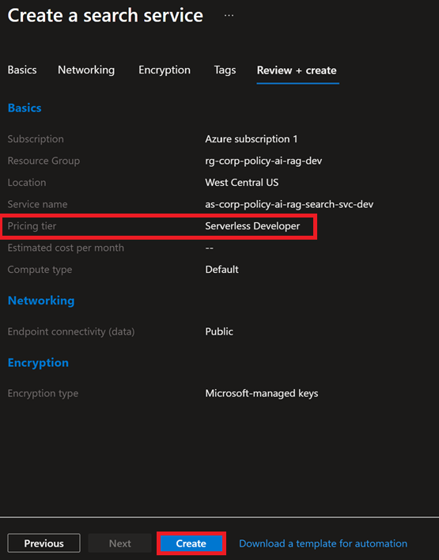
- Go to Properties to configure/confirm default AI Search Service properties.
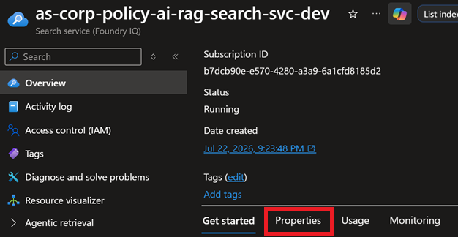
- Confirm the following:
- NetworkConnectivity mode is set to Public.
- OthersAPI Access control is set to API keys and role-based access control (RBAC).
- OthersSemantic ranker is set to Free – (i.e. current developer version of service).
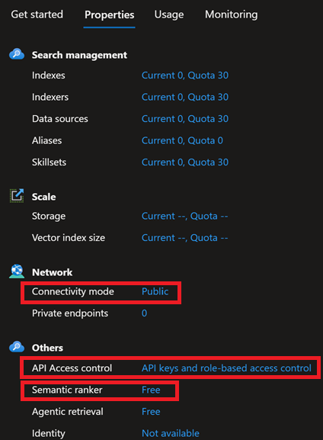
- Go to Security + networkingIdentity to configure the identity.
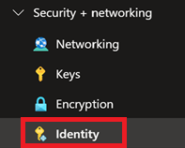
- Turn on the Status toggle button to enable System Assigned - Managed Identity.
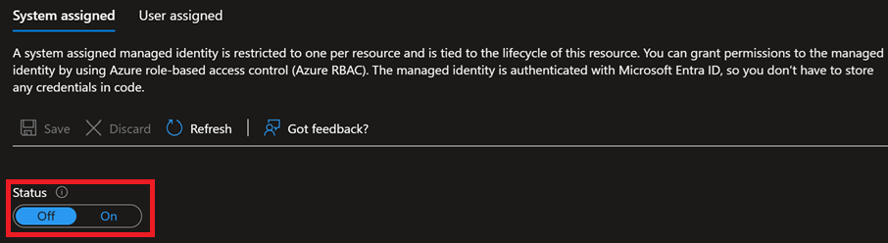
- Click the Save button to enable Managed Identity.
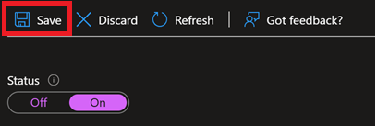
- Click Yes button.
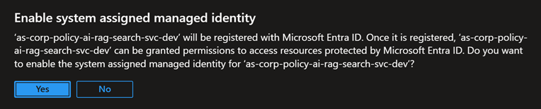

- Click Azure role assignments button to assign user roles to user identity.

- Add or select the following:
- Scope: Resource group
- Subscription: Select your Azure subscription.
- Resource group: Select the Resource group that your Azure AI Service resides in.
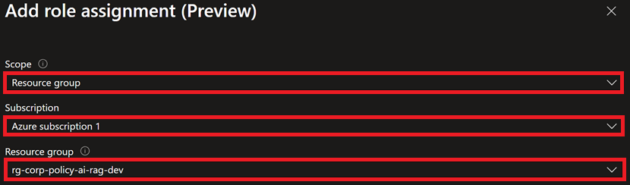
- Select Role (i.e. Search Service Contributor) and enter the Role Name you want add to the Azure AI Service identity. Click Enter key to add the role.
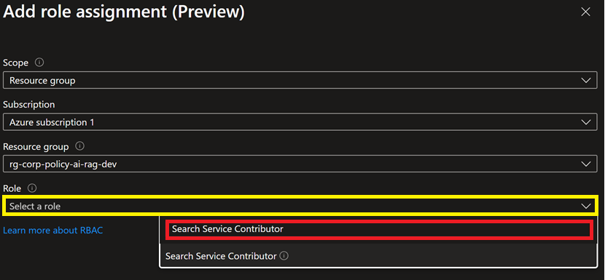
- Click Save button.


- Confirm Role was added to identity and click Add role assignment (Preview) button to add additional role.
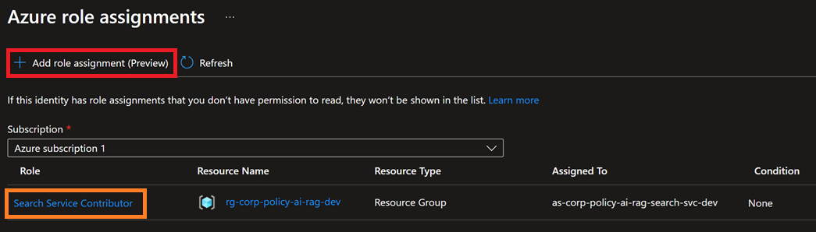
- Add or select the following:
- Scope: Resource group
- Subscription: Select your Azure subscription.
- Resource group: Select the Resource group that your Azure AI Service resides in.
- Role: Add Search Index Data Contributor role.
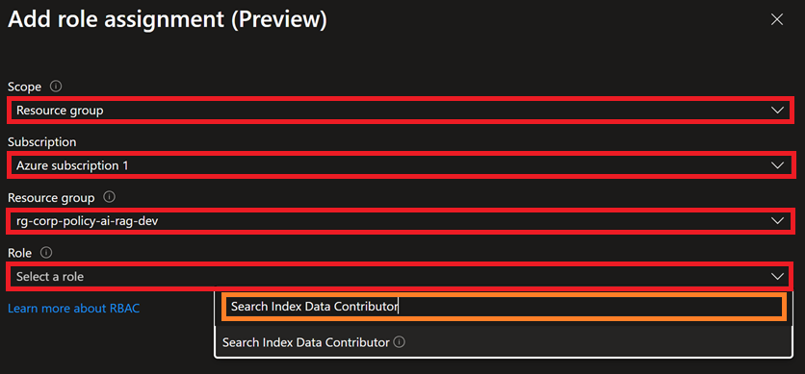
- Click Save button.


- Click Add role assignment (Preview) button to add Storage Blob Data Reader role to System Assigned Managed Identity.
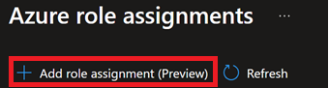
- Add or select the following:
- Scope: Resource group
- Subscription: Select your Azure subscription.
- Resource group: Select the Resource group that your Azure AI Service resides in.
- Role: Add Storage Blob Data Reader role.
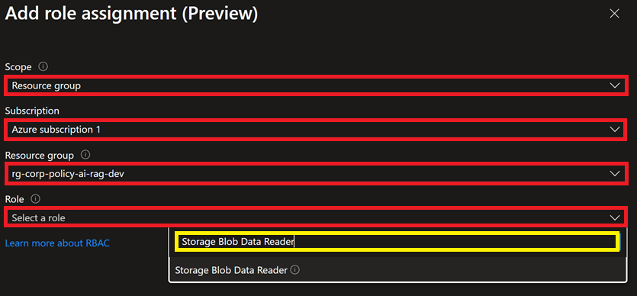
- Click Save button to save the Role Assignment.

- Click Add role assignment (Preview) button to add Storage Blob Data Reader role to System Assigned Managed Identity.

- Add or select the following:
- Scope: Resource group
- Subscription: Select your Azure subscription.
- Resource group: Select the Resource group that your Azure AI Service resides in.
- Role: Add Cognitive Services OpenAI User role.
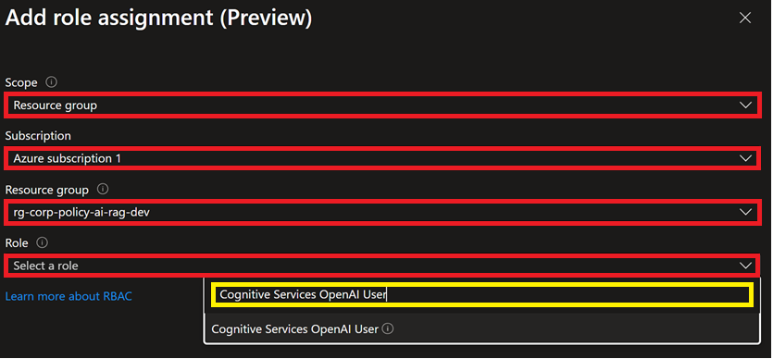
- Click Save button to save the Role Assignment.
- Finished.

